

Functional Requirements Document (FRD)
  - Intermex LLC – J876187, J885047

Copyright© 2018, Oracle and/or its affiliates. All rights reserved.
Any reproduction or distribution of any part of this document without the prior written permission of Oracle + NetSuite is strictly prohibited.
The information included in this document is confidential and proprietary information of Oracle + NetSuite.
Version: March 3, 2022

Oracle + NetSuite
2955 Campus Drive, Suite 100
San Mateo, CA. 99403-2511

Project Information
Implementation Name | Custom Checkout
Customer Name (Number) | Intermex
Job Name (Number) | J876187
Document Owner | Alain Komin
Project Manager | Alain Komin
Lead Developer | Ilan Daniele

Document Version History
Rev | Date | Author(s) | Change Summary
1.0 | 08/29/2022 | Alain Komin | Initial Draft

Table of Contents
1 Business needs 4
2 Impacted areas/modules 4
3 Acceptance criteria 5
4 Solution proposal 5
4.1 Configuration Record 5
4.2 Item Record 5
4.3 Cart 6
4.4 Checkout 6
5 Prerequisites 7
6 Assumptions 7
7 Constraints and limitations 8
8 Risks 8
9 Current site look and functionality 9
9.1 Equipment order page 11
9.2 Marketing order page 19

Business needs

As a logged in Sales Representative, I would like to see a custom checkout page where multiple custom fields are available for completion, so that, I am able to add all relevant information to the Equipment or Marketing orders and submit it.

Impacted areas/modules
The Configuration Record will be modified to add the page to define the fields and their position at checkout for each type of order.

The

Checkout page will be updated to allow adding custom fields (including dropdowns) following a defined order.
The Cart will be modified to display a pop-up error message upon adding items of different order type.
Some of the lists that are needed to be displayed at checkout are:
- Order Type
- Priority
- System
- Fiesta Van / Canopy Event

- Agent Classification
- Region
The Login page will have a new field to be validated before granting access to the site.

Acceptance criteria

This customization will allow the administrator to select all necessary transaction body fields to be displayed at checkout based on the type of order (Marketing or Equipment). It will be possible to specify the order in which the fields will be displayed.

Solution proposal

A new extension will be created to add the described functionality to the Configuration record, Item Record and webstore’s Cart and Checkout pages.

Configuration Record
The next columns will be added to a new tab in the configuration record to allow the administrator to define the checkout page:
- Field ID Transaction body field ID
- Position Position of the field in the checkout page. Smaller numbers display first (from top to bottom)
- Field type Type of field
- Field Label Label to be displayed on the left of the field
- Placeholder Info to be displayed in the entry field (HTML will be allowed for messages)
- Required Determines if the field is mandatory or not
- Field Length Field capacity
- Order Type The field will be displayed on Equipment or Marketing orders
Example:
FIELD ID | POSITION | FIELD TYPE | FIELD LABEL | PLACEHOLDER | REQUIRED | FIELD LENGTH | ORDER TYPE
Cust_field_agency | 1 | Free-Form Text | Agency |  | T | 6 | Equipment
Cust_order_type | 2 | List | Order Type | Select order type… | T |  | Equipment
Cust_order_sent_to | 3 | List | This order will be sent to |  |  |  | Marketing
Cust_im_rse | 4 | Check Box | I´m RSE |  |  |  | Equipment
Cust_im_rse | 5 | Check Box | I´m RSE |  |  |  | Marketing
 | 6 | Message |  | This is an informational message to be displayed instead of a field. |  |  | Marketing
Cust_delivery_date | 7 | Date | Delivery Date |  |  |  | Equipment

Field types:
- Free-Form Text field type will be treated as input fields.
- List field type will display as dropdown lists displaying the list record associated contents.
- Checkbox field type will display as a T/F checkbox option.
- Message field type will display as not editable text.
- Date field type will show as a date picker.

Item Record
As some items belong to the “Equipment” order and some to the “Marketing” order, a new field (list type with 2 options: Equipment and Marketing) will be added to the Item record to set it as Equipment or Marketing item. This field is mandatory.
This new list in the item record will be used to show the correct fields at checkout, based on the selection in the Configuration record for each field.

Cart
There will be a new validation that will be executed upon adding each new item to the Cart. If there is already an item in the cart, the new item to be added must have the same option as the existing ones in the cart (Equipment or Marketing). If the item in the cart is Marketing type and the Sales Rep is adding an Equipment one, a pop-up error will be displayed informing that the items are incompatible. This new item will not be added to the Cart. The same error will be displayed if the item in the cart is Equipment and the item to be added is Marketing type.
This error message will be set in the Configuration record and will be available to be updated by the Administrator.

Checkout
As the checkout process will be totally custom and there is no shipping information or payment information, it will be necessary to remove all native checkout sections and just display the fields configured.
Shipping and Payment information will be turned off from the Website Record.
The checkout page will be configured as a One Page Checkout (OPC).
To print the fields in the screen, the Order Type will be determined by the items in the Cart. All transaction body fields configured for that order type will be displayed in the checkout page. Only one field will be displayed per row following the order specified during configuration. First field will be the one with smaller position. Last field will be the one with the largest position.
After submitting the Order, a validation will be triggered to determine that the Agency Code exists in a Customer record and GLOBAL CASH STATUS is not Terminated. If it doesn’t exist or the status is Terminated, an error will be displayed, and the order will not be saved. The Sales Rep will need to fix the agency ID and submit the order again.
After successfully submitting the Order, an external process built by Gratuz Team will perform some changes to the transaction, like changing the customer form the Sales Rep to the Agency.

My Account
The Recent Purchases from the Overview page and the Purchase History page will be removed from My Account as all the orders will be associated with the Agencies and not with the Sales Reps.

Prerequisites

All necessary standalone Items exist and were flagged to be displayed in the webstore.
All necessary kit items exist and were flagged to be displayed in the webstore.
All necessary drop ship and special-order items exist and were flagged to be displayed in the webstore.
All necessary item options (e.g.: Additional Notes for Supplies) exist.
All necessary items were added to a Commerce Category.
All necessary items were flagged as Marketing or Equipment for this customization to work properly and for the checkout to look and behave as needed.
All necessary Transaction Body fields and lists were created for this customization to work properly and for the checkout to look and behave as needed.
Complete list of fields needed at checkout will be determined by Intermex.
Some of the current site lists are:
- Order Type (list)
- Priority (list)
- System (list)
- Fiesta Van / Canopy Event (list)
- Agent Classification (list)
- Region (list)

Assumptions

- All Sales Reps are Customer Records and have access to the store
- The email and password for each Sales Reps was set by Intermex NS administrator
- All necessary Items were created by Intermex NS administrator
- All necessary Items were set as Marketing or Equipment by Intermex NS administrator
- All necessary Categories were created by Intermex NS administrator
- All necessary Transaction Body Fields were created by Intermex NS administrator
- All necessary Lists were created by Intermex NS administrator
- All necessary item options were created and added to items by Intermex NS administrator
- All necessary fields to be displayed at checkout were added to the new page of the configuration record by Intermex NS administrator
- The items will be added to the Cart from the native shopping pages and not from the checkout page as on SharePoint
- The checkout page will display one custom field per row. There will be no option to display one field next to the other on the same row

Constraints and limitations
GUIDELINE FOR THIS SECTION (DELETE TEXT BELOW ONCE THIS SECTION IS COMPLETED)
This section should list all the constraints and limitations known until the date.
[This section is optional as final output on the document. The contents of this section will depend on if limitations exists or not. Although the section is optional it must be part of the analysis process to determine if it is needed or not.]
For example:
- BOPIS is not compatible with scriptable cart.
- Customer Item pricing is limited to 10.000 records.
- Etc.
(DELETE TEXT ABOVE ONCE THIS SECTION IS COMPLETED)

Risks
GUIDELINE FOR THIS SECTION (DELETE TEXT BELOW ONCE THIS SECTION IS COMPLETED)
This section should list all the risks that this solution may face or introduce to the system.
[This section is optional as final output on the document. The contents of this section will depend on if risks exists or not. Although the section is optional it must be part of the analysis process to determine if it is needed or not.]
For example:
- If a third party integration is needed then there is a risk that the third party could break eventually and impact the site.
- If working with SCS and CSS rules are being used to achieve certain behavior then the theme could be updated in the future and the CSS rules might no longer work (although this is highly improbable the risk exists).
- Etc.
(DELETE TEXT ABOVE ONCE THIS SECTION IS COMPLETED)

Current SharePoint site look and functionality
Homepage has 2 options on the right, for Marketing and Equipment orders.
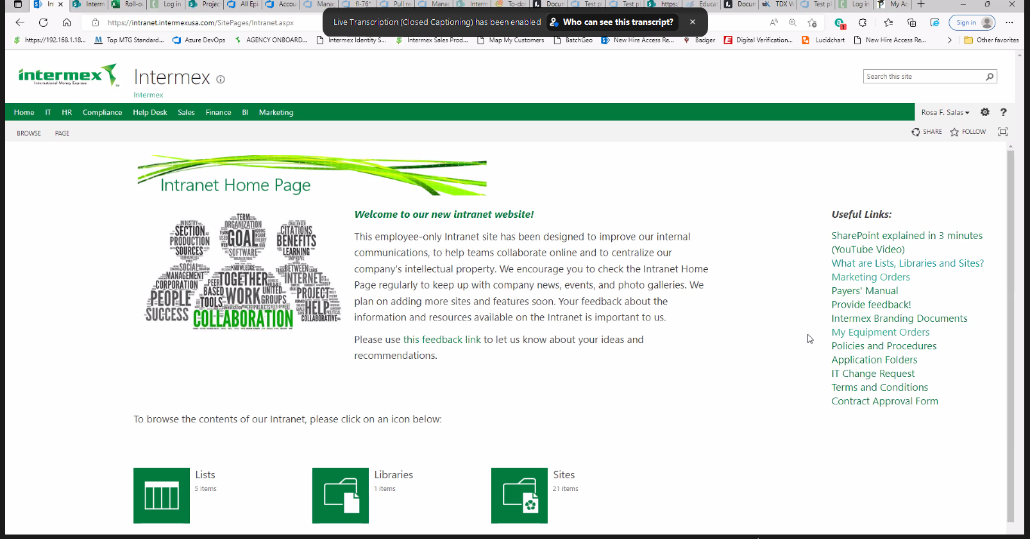
Each link takes the Sales Rep to the list of those type of orders.
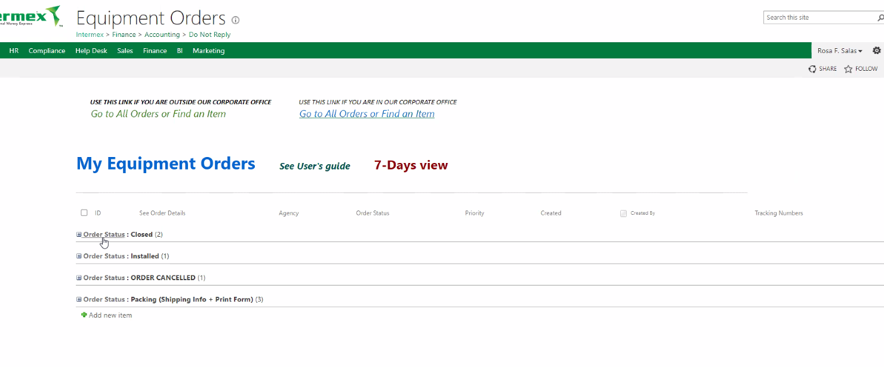

This new column will be added through Configuration Record.
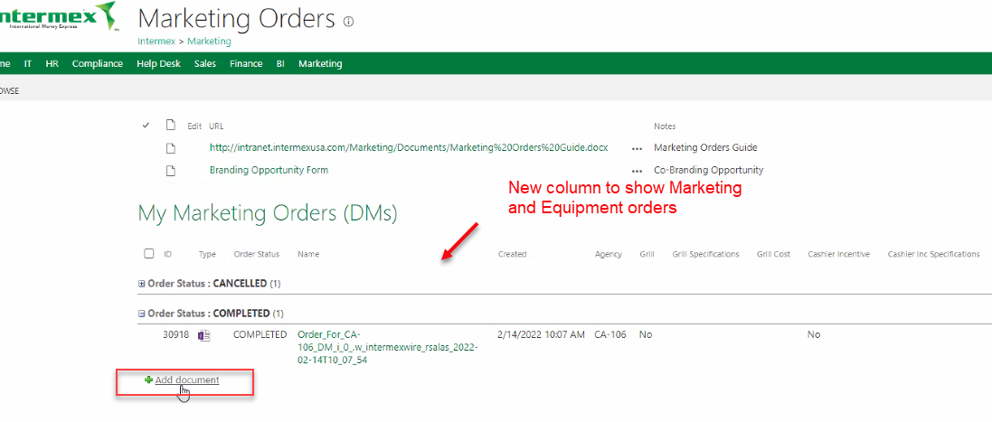
Add document link takes the Sales Rep to the order page.
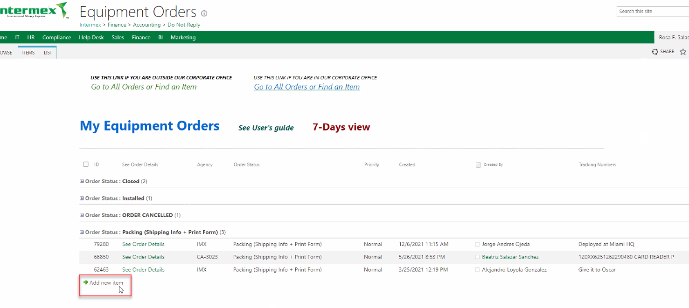

Equipment order page
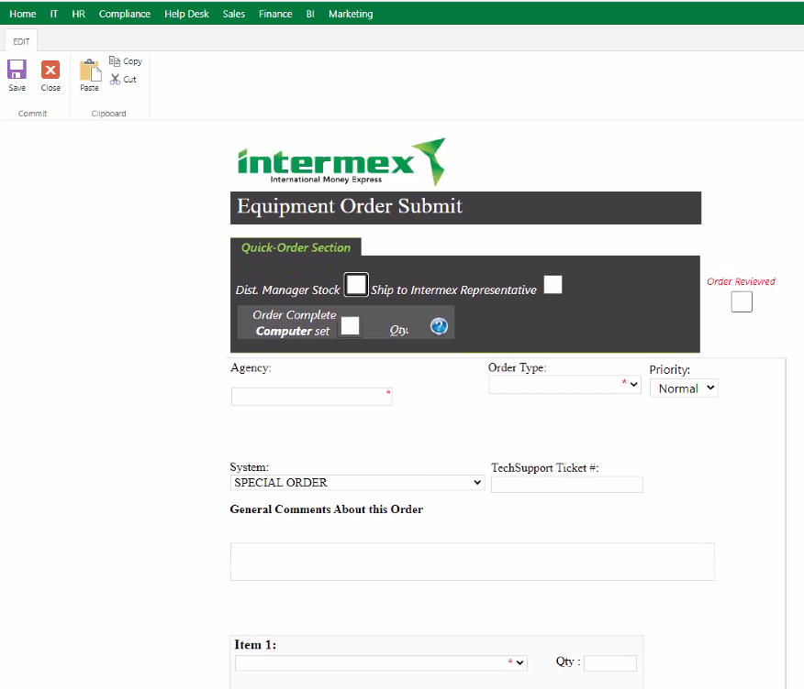

Dist. Manager Stock checked disables the Agency text-box and auto selects the Order Type to District Manager Stock. It also shows a Ship equipment to DM! label.
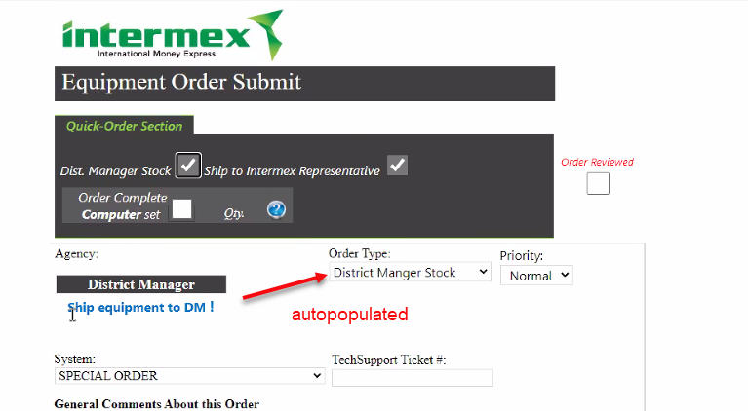

If Ship to Intermex Representative is checked, what happens here?
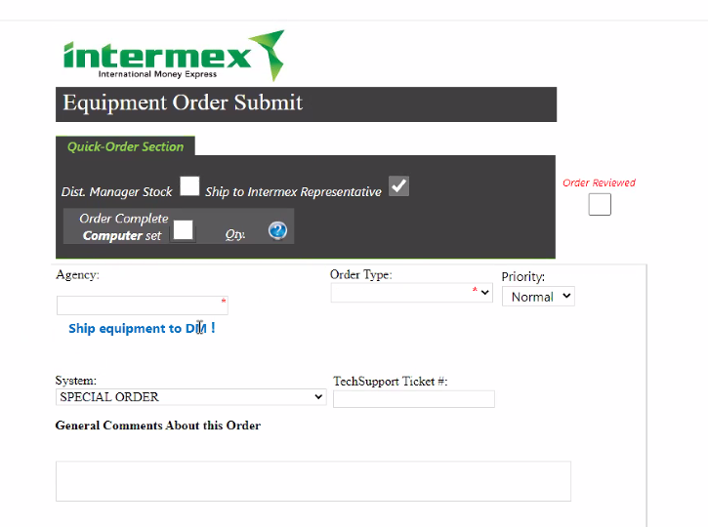

Order Complete Computer set checkbox automatically add all parts of the computer. Qty selector has limited options: 0 and 1.
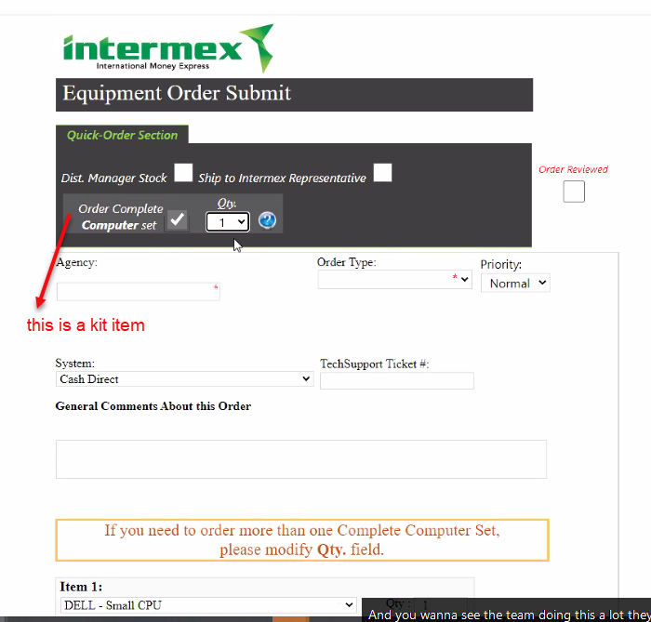
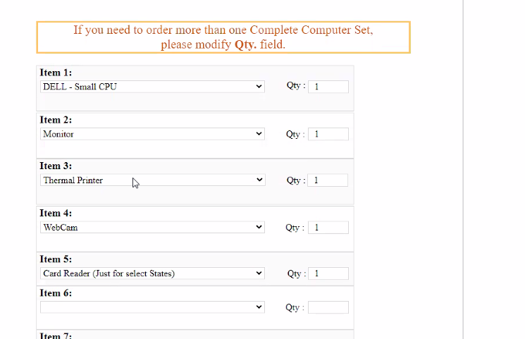
If the item the Sales Rep is looking for is not in the list, they select Supplies and adds a mandatory text with the item needed.
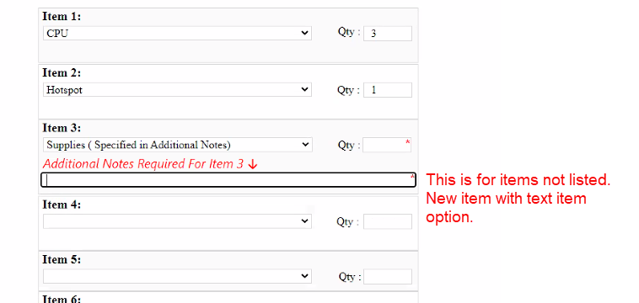

Help icon shows a modal with information. This will be the Kit Item´s Detailed Description.
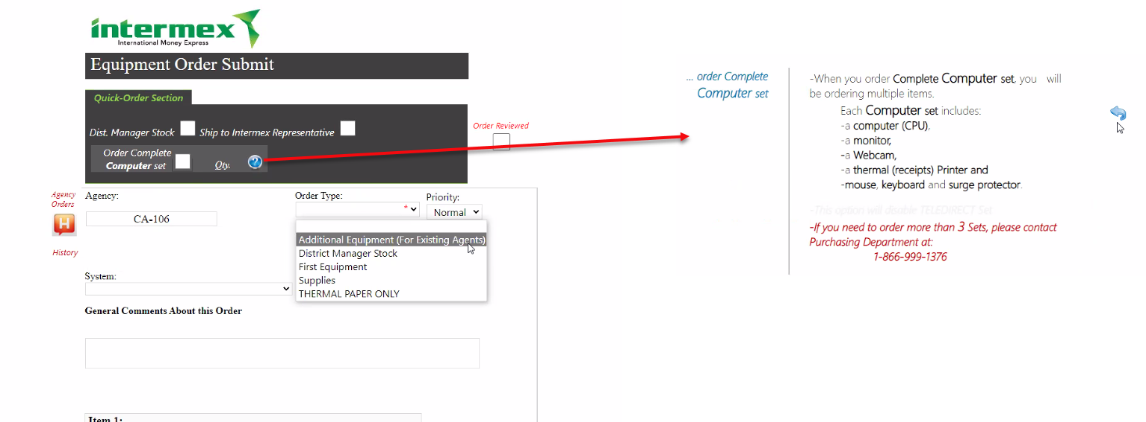
Some Order Types and High Priority options shows red messages and require mandatory Comments. We will make this field mandatory so all orders will have this field populated. Sales Rep. can add N/A if not applicable.
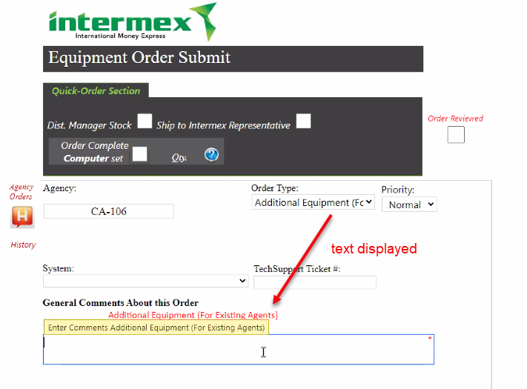
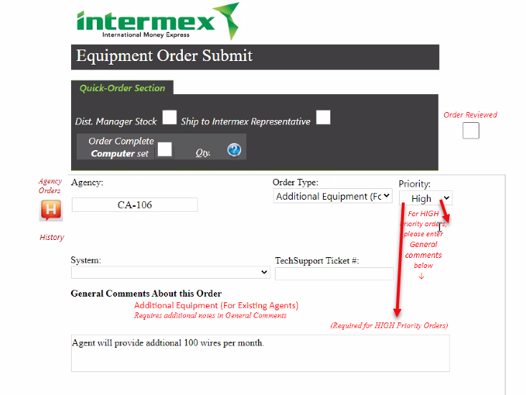

Before submitting the order, the Agent must check the Order Reviewed checkbox. Use native T&C checkbox.
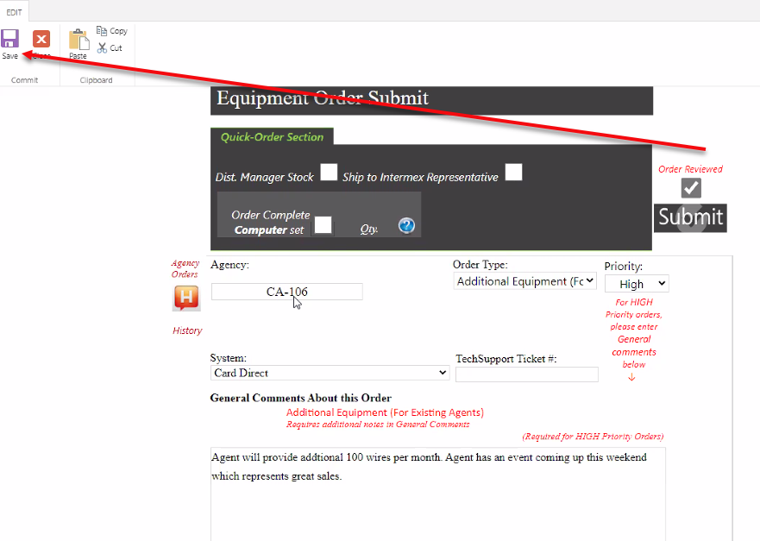
Equipment Order fields (final list to be determined by Intermex):
Name | Type | Action | SCA Functionality
Dist. Manager Stock | Checkbox | If checked
Ship to Intermex Representative | Checkbox
Order Complete Computer Set | Checkbox |  | This will not be in the checkout. A kit item will be created with all parts and will be added to the cart from the shopping pages.
Order reviewed | Checkbox
Agency | Text | No validation.
Order Type | List
Priority | List
System | List
Tech Support ticket # | Text
General Comments About this Order | Text | Mandatory only for certain order types and priority. | This will be a new transaction body field exposed in the checkout and mandatory for all orders.
Item ## | List |  | This will not be in the checkout. A kit item will be created with all parts and will be added to the cart from the shopping pages.
Qty | Text |  | This will not be in the checkout. A kit item will be created with all parts and will be added to the cart from the shopping pages.
Additional Notes | Text |  | This will be an item option associated to a new item. This will allow the user to add to the order a generic item with a mandatory description.

Marketing order page
Orders can be for My Self (Sales Rep) or An Agency. Agency field must be mandatory if An Agency was selected.
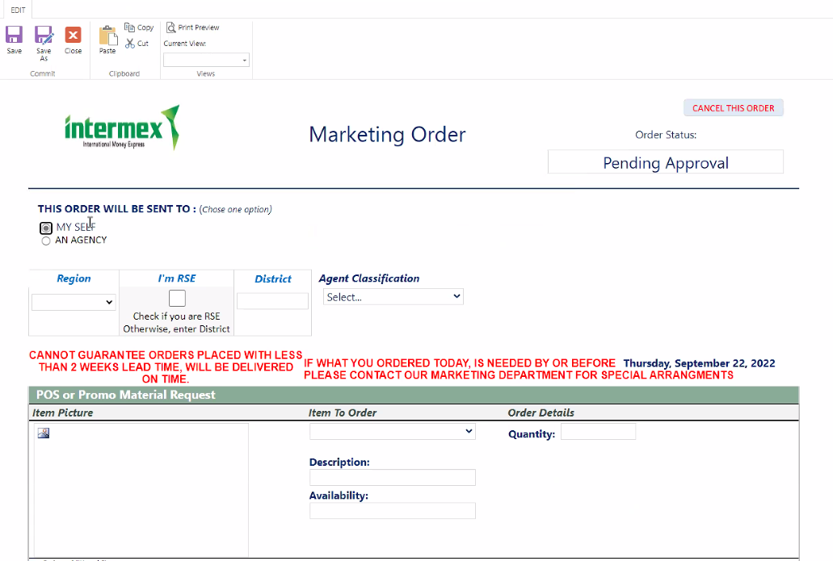
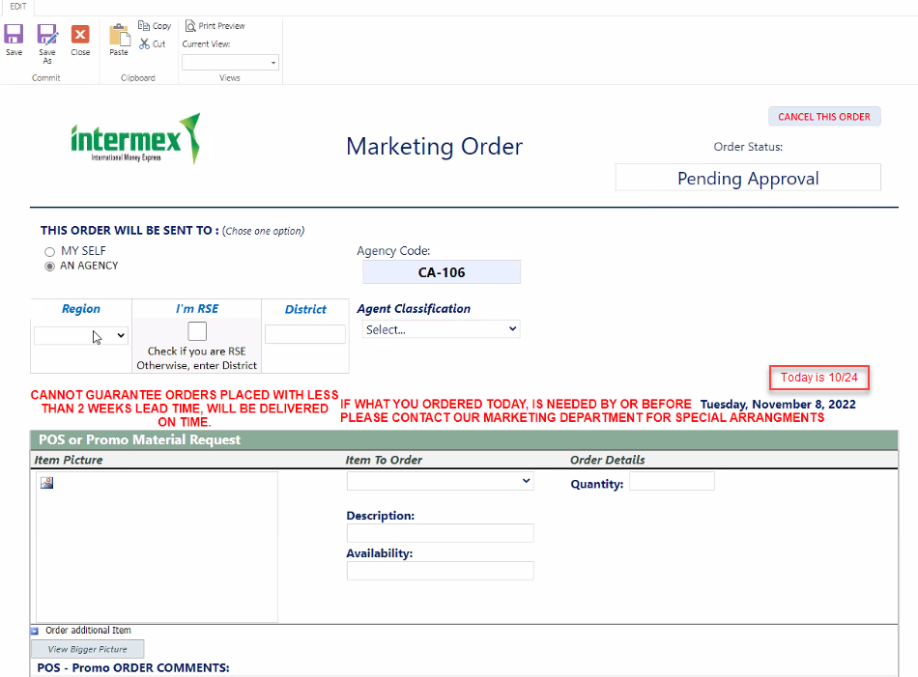
Red messages not needed. Add text option to the configuration to add messages in HTML format.
Region and I am RSE fields will not be needed.
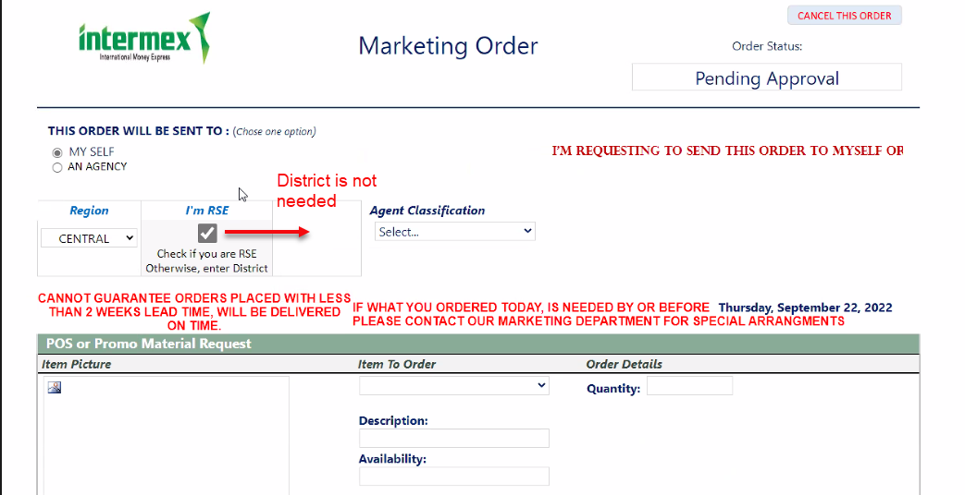
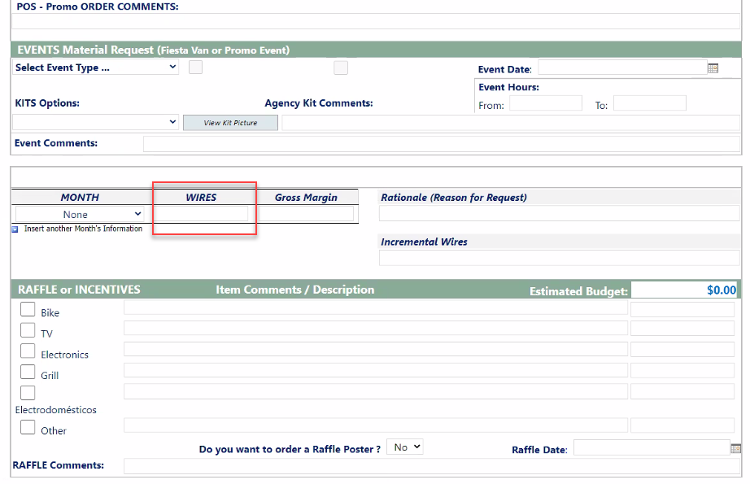
Event items will have item options:
- Event Date
- Event Hours
- Wires
Raffle items will have item options:
- Want a Poster?
- Raffle Date
Nothing related with $ or budget is needed.

Special Order items will be configured as needed.
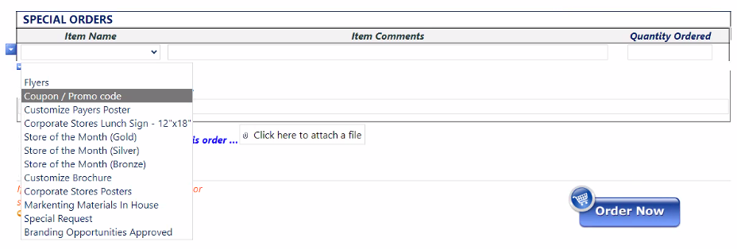
Item Options will be added to the necessary items based on business needs.
Example for Coupon/Promo Code items:
- Promo Code: WA0945
- Discount: $2
- Length: 7/1 to 9/31
- Cost, How much % Intermex and how much % the agent?
- Types of wires (specific corridor or all wires)
- Uses (singles use, multiple use?) 1 X customer, Once X month

Branding Opportunities items: Need file upload as item option.

Oracle + NetSuite Professional Services and Intermex LLC are in agreement that the information documented above is accurate and representative of the customer’s business needs. This document will act as the basis for all subsequent implementation activities.
Document delivery date: MM/DD/YYYY

